Cloud Architect, Cloud Network Engineer

Compute, Networking

**Lab Steps**

Task 1: Sign in to AWS Management Console

1. Click on the  button, and you will get redirected to AWS Console in a new browser tab.
2. On the AWS sign-in page,
   * Leave the Account ID as default. Never edit/remove the 12 digit Account ID present in the AWS Console. otherwise, you cannot proceed with the lab.
   * Now copy your **User Name** and **Password** in the Lab Console to the **IAM Username and Password** in AWS Console and click on the **Sign in** button.

Once Signed In to the AWS Management Console, Make the default AWS Region as **US East (N. Virginia) us-east-1.**

Task 2 : Launching First EC2 Instance

1. Make sure you are in the **US East (N. Virginia) us-east-1** Region.
2. Navigate to **EC2** by clicking on the  menu in the top, then click on **EC2** in the **Compute** section.
3. Navigate to**Instances**on the left panel and click on **Launch Instances.**
4. Search and Choose Amazon Linux 2 AMI:
5. Navigate to **Instances**on the left panel and click on **.**
6. Name : Enter ***MyEC2Server***

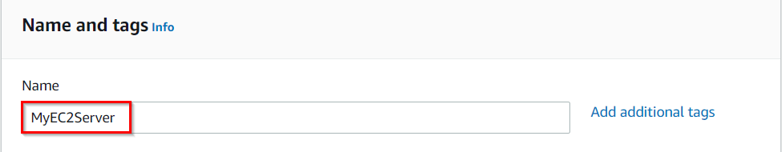

1. **For Amazon Machine Image (AMI):** Search for **Amazon Linux 2 AMI** in the search box and click on the **Select** button.  
   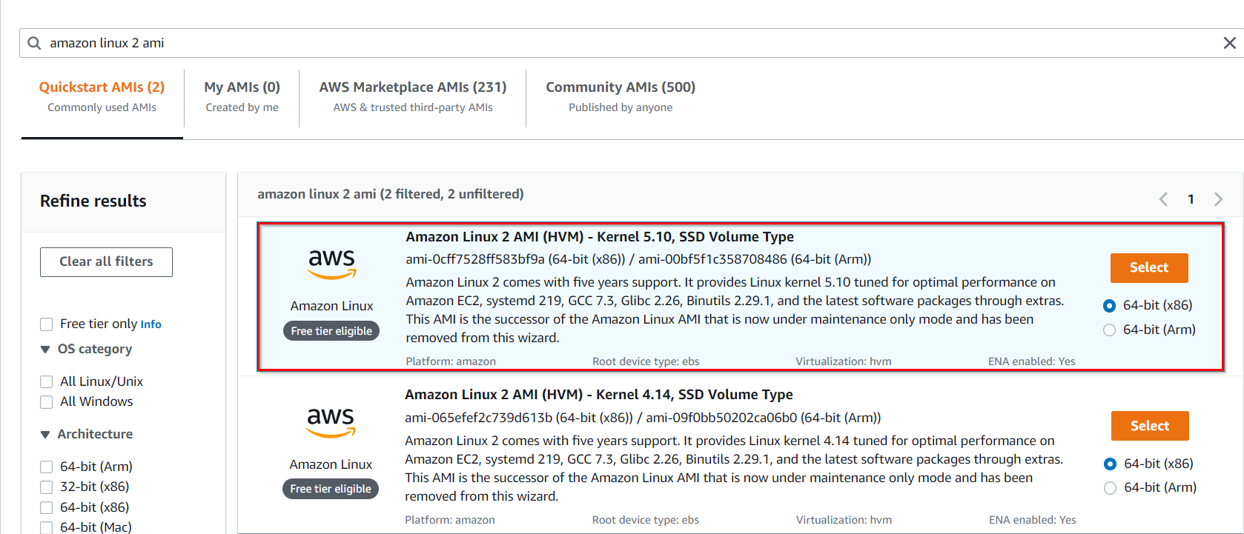
2. **Note: if there are two AMI's present for Amazon Linux 2 AMI, choose any of them.**
3. **For Instance Type:** select **t2.micro**

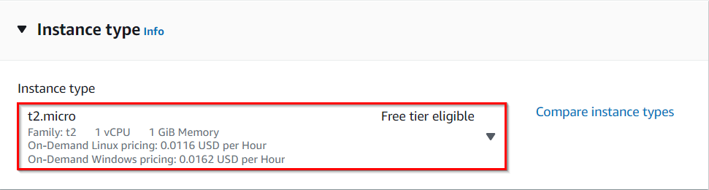

1. **For Key pair:**Select **Create a new key pair**Button
   * Key pair name: **WhizKey**
   * Key pair type:**RSA**
   * Private key file format: **.pem**
2. Select **Create key pair** Button.

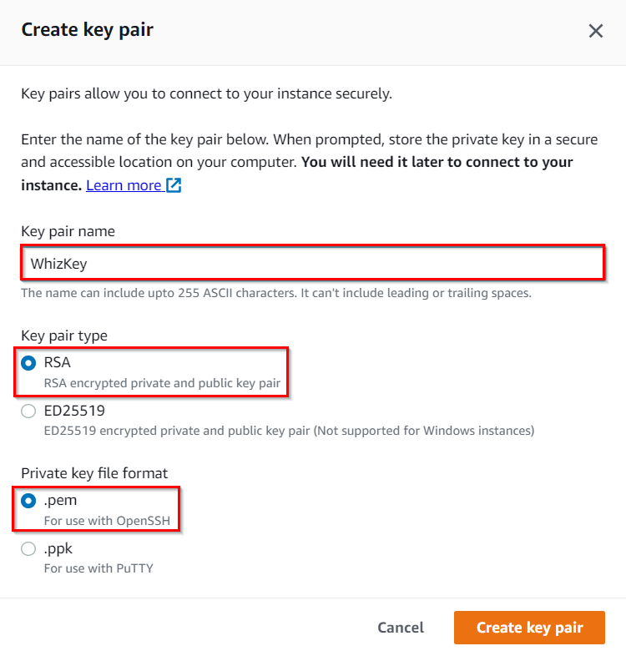

1. In Network Settings Click on **Edit**:
   * Auto-assign public IP: **Enable**
   * Select **Create new Security group**
   * Security group name : Enter***MyEC2Server_SG***
   * Description : Enter***Security Group to allow traffic to EC2***

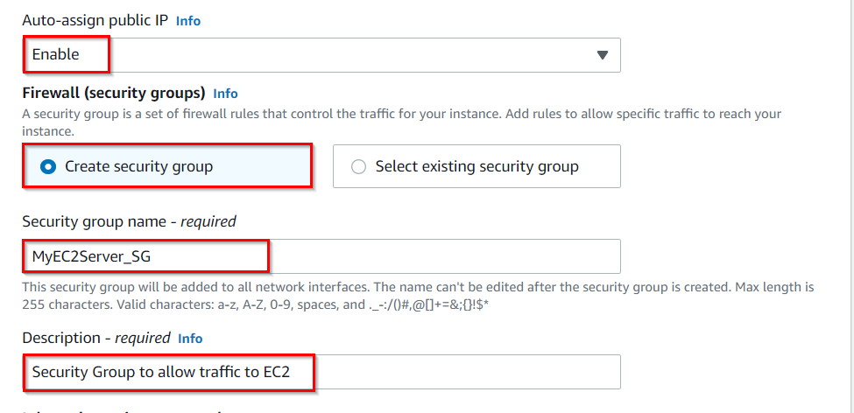

1. Check**Allow SSH from** and Select **Anywhere** from dropdown

* To add **SSH**,
  1. Choose Type: 
  2. Source: Select 
* For **HTTP,**Click on**Add security group rule**
  1. Choose Type: 
  2. Source:  Select 
* For **HTTPS,**Click on**Add security group rule**
  1. Choose Type: 
  2. Source:  Select 

1. Click on ****and under the **User data:** section, enter the following script to create an HTML page served by an Apache httpd web server.

|  |
| --- |
| #!/bin/bash  sudo su  yum update -y  yum install httpd -y  echo "<html><h1> Welcome to Whizlabs Server 1 </h1><html>" > /var/www/html/index.html  systemctl start httpd  systemctl enable httpd |

**Note: After pasting the user data, make sure to remove extra spacing.**

1. Keep Rest thing Default and Click on**Launch Instance**Button.
2. Select **View all Instances** to View Instance you Created
3. **Launch Status:** Your instance is now launching, Click on the instance ID and wait for complete initialization of the instance till status changes to **Running**.

Task 3 : Launching Second EC2 Instances

1. Make sure you are in the **US East (N. Virginia) us-east-1** Region.
2. Navigate to **EC2** by clicking on the  menu in the top, then click on **EC2** in the **Compute** section.
3. Navigate to**Instances**on the left panel and click on **Launch Instances.**
4. Search and Choose Amazon Linux 2 AMI:
5. Navigate to **Instances**on the left panel and click on **.**
6. Name : Enter ***MyEC2Server2***

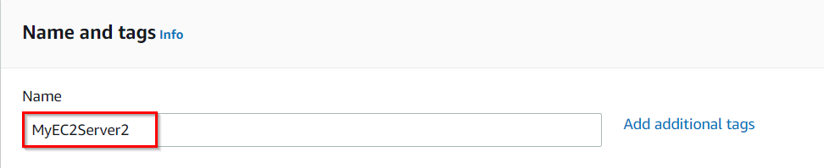

1. **For Amazon Machine Image (AMI):** Search for **Amazon Linux 2 AMI** in the search box and click on the **Select** button.  
   
2. **Note: if there are two AMI's present for Amazon Linux 2 AMI, choose any of them.**
3. **For Instance Type:** select **t2.micro**



1. **For Key pair:**Select the key you created previously
2. In Network Settings Click on **Edit**:
   * Auto-assign public IP: **Enable**
   * Select **Select existing security group**and Select the group created earlier
3. Click on ****and under the **User data:** section, enter the following script to create an HTML page served by Apache httpd web server:

|  |
| --- |
| #!/bin/bash  sudo su  yum update -y  yum install httpd -y  echo "<html><h1> Welcome to Whizlabs Server 2 </h1><html>" > /var/www/html/index.html  systemctl start httpd  systemctl enable httpd |

* **Note: After pasting the user data, make sure to remove extra spacing.**

1. Keep Rest thing Default and Click on**Launch Instance**Button.
2. Select **View all Instances** to View Instance you Created
3. **Launch Status:** Your instance is now launching. Click on **View Instances.**In the dashboard find your instance and wait for complete initialization of the instance until the instance state changes to running.

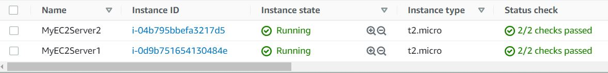

Task 4: Creating the Target Group and Load Balancer

1. In the **EC2** Console, Navigate to **Target Groups**, present in the left panel under **Load Balancing**.
2. Click on the **Create target group** button.
3. For **Step 1, Specify group details**
   * Under Basic configurations,
     + Choose a target group:  Choose **Instances**
     + Target group name:  Enter ***MyTargetGroup***
   * **Keep all the settings as default.**
   * Scroll to the end of the page and click on the **Next** button.
4. For **Step 2, Register targets**
   * Select both instances and click on the **Include as pending below** button.  
     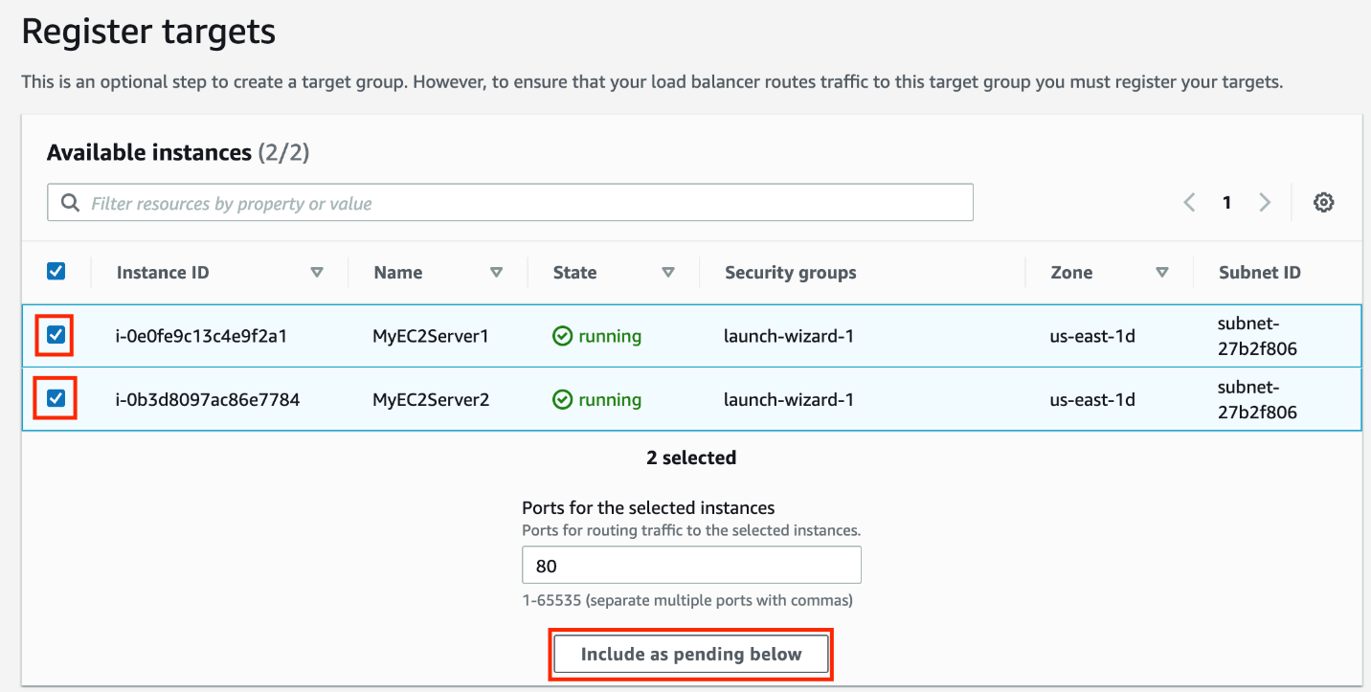
   * Instances will be present in the Review targets part, having health status as **Pending**.
   * Click on the **Create target group** button.
5. **The Target group is now created.**
6. In the EC2 console, navigate to  in the left-side panel.
7. Click on at the top-left to create a new load balancer for our web servers.
8. **Select Load Balancer Type**: Under the **Application load balancer**, click on **Create** button.
9. To create an Application load balancer, **configuring the load balancer** as below
   * For the **Basic configuration** section,
     + Name: Enter ***MyLoadBalancer***
     + Scheme: Select**Internet-facing**
     + IP address type: Choose **IPv4**
   * For the **Network mapping** section:
     + VPC: Select **Default**
     + Mappings:**Select all the Availability zone present**
   * For the Security groups section,
     + Select the ***MyEC2Server_SG* Security group** from the dropdown and **remove the default security group**.
   * For the **Listeners and routing** section,
   * The listener is already present with Protocol HTTP and Port 80.
     + **Select the target group MyTargetGroup for the Default action forwards to option.**
10. Keep the tags as default and click on the **Create load balancer** button.
11. **You** **have successfully created the Application Load balancer.**Click on the**View load balancers button.**
12. Wait for 2 to 3 minutes for the load balancer to become **Active**.

Task 5: Testing the Elastic Load Balancer

1. Click on 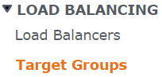 from the left menu section.
2. Select **MyTargetGroup**and navigate to the **Targets** tab below.
3. **Wait** until the **status** column of the instances changes to **healthy**(this means both web servers have passed ELB health check**)**

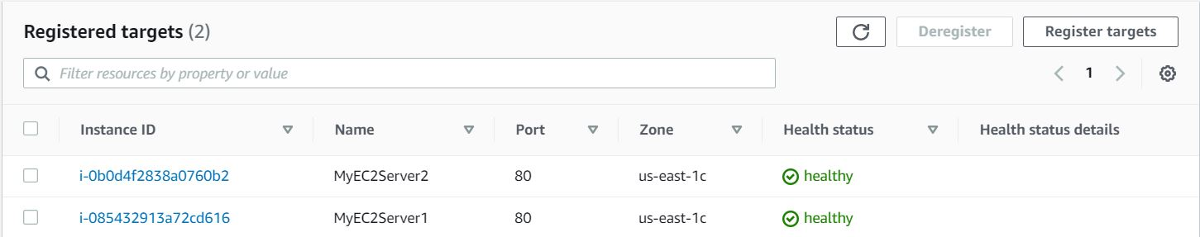

1. Next, navigate to  and notice the state of ELB is **active.**
2. Copy the **DNS name** of the  ELB and enter the address in the **browser**.
   * **DNS Example: MyLoadBalancer-913911171.us-east-1.elb.amazonaws.com  
     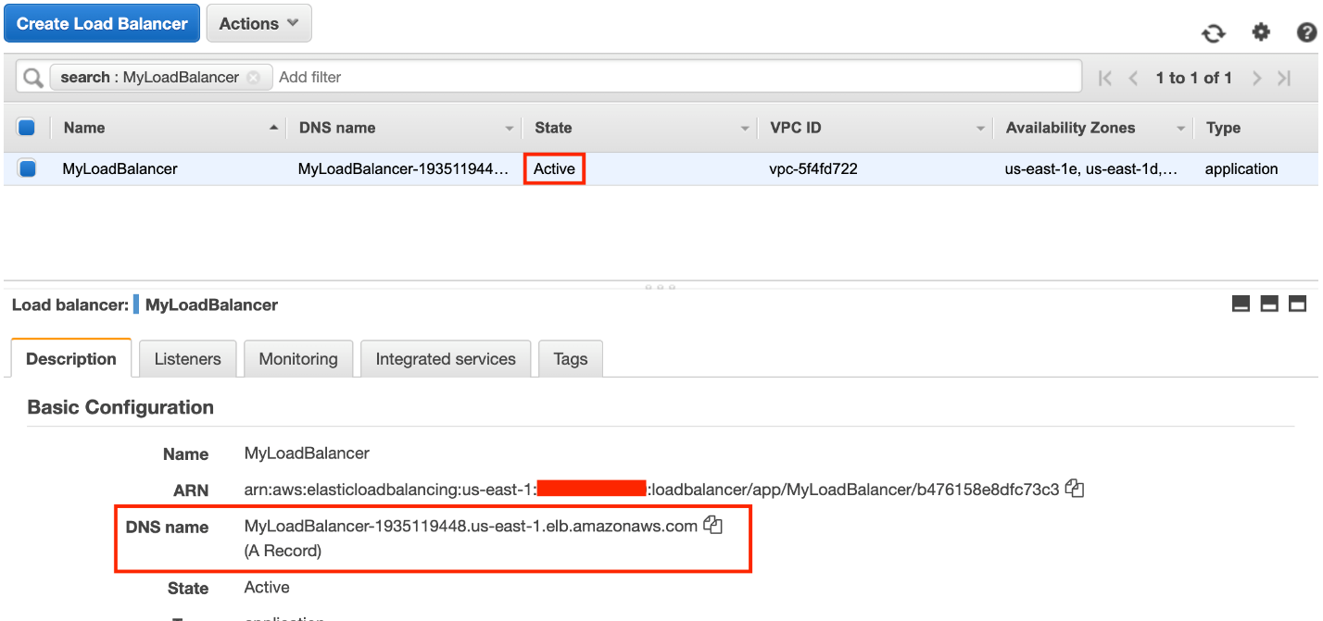**
3. You should see the **index.html**page content of Web Server 1 or Web Server 2

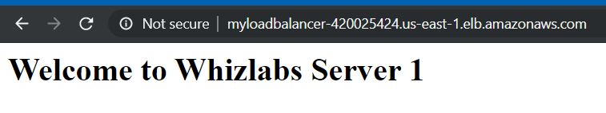

1. Now**Refresh** the page **a few times**. You will observe that the index pages change each time you refresh.

* **Note: The ELB is equally dividing the incoming traffic to both servers in a Round Robin manner**.

1. For testing, if ELB is working properly,
   * In the left side menu, scroll up and navigate back to the  page.
   * Select **MyEC2Server1,** click on **Instance State** and click on **Stop instance**to stop the EC2 instance.

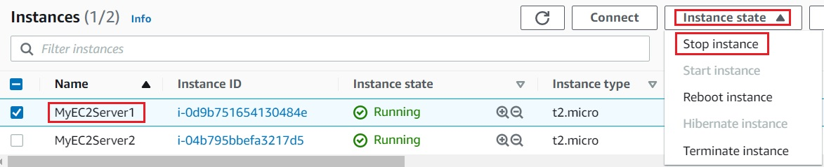

* Once **MyEC2Server1**is stopped, navigate to  . Select the **MyTargetGroup**, Click on the **Targets**.
* It will say that the stopped instance **MyEC2Server1**is **unused**.

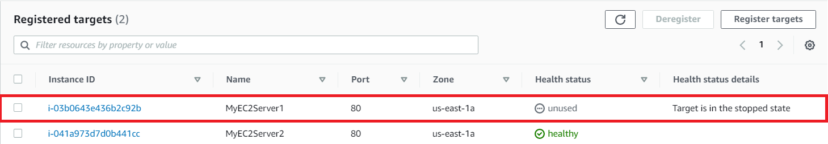

* **Refresh** the ELB domain name URL in **Browser**, and notice the HTML webpage remains visible. The ELB is only rendering the HTML page from the **MyEC2Server2**instance.

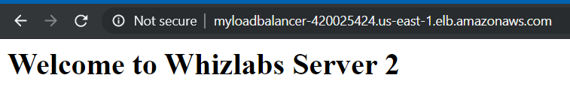

Task 6: Validation Test

1. Once the lab steps are completed, please click on the  button on the left side panel.
2. This will validate the resources in the AWS account and displays whether you have completed this lab successfully or not.
3. Sample output :

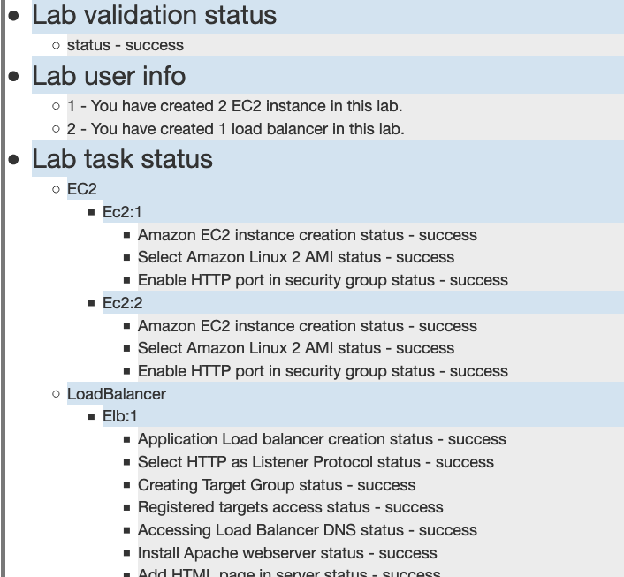

Task 7: Delete AWS Resources

Deleting Load balancer

1. In the EC2 console, navigate to  in the left-side panel.
2. **MyLoadBalancer** will be listed here.  
   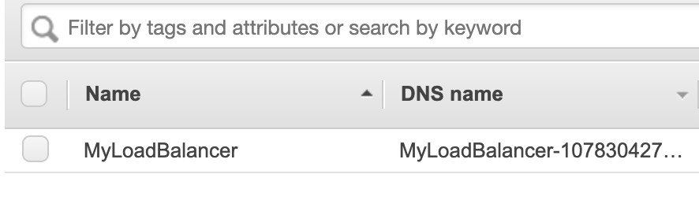
3. To **delete** the load balancer, need to  perform the following actions:
   * **Select** the load balancer,
   * Click on the **Actions** button,
   * select the **Delete** option.  
     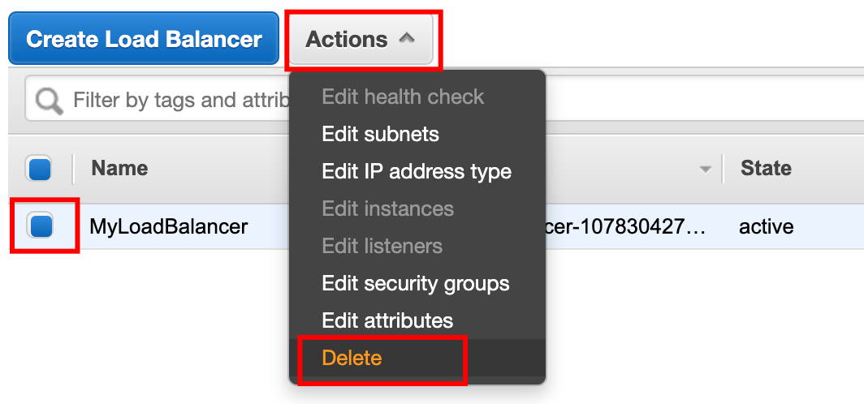
4. Confirm by clicking on the **Yes, Delete** button when a pop-up is shown.  
   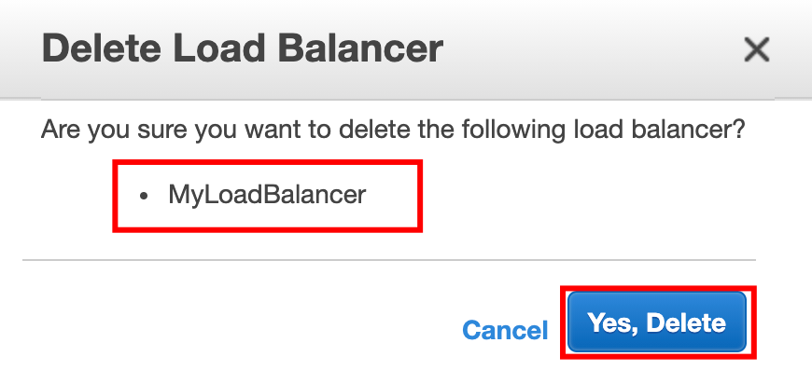
5. Web-server-LG will be deleted immediately.

Deleting Target groups

1. In the EC2 console, navigate to in the left-side panel.
2. **MyTargetGroup** will be listed here.  
   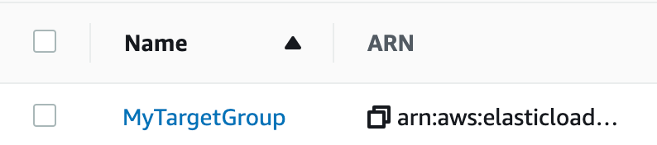
3. To delete the **target group**,you need to perform the following actions:
   * **Select** the load balancer,
   * Click on the **Actions** button,
   * select the **Delete** option  
     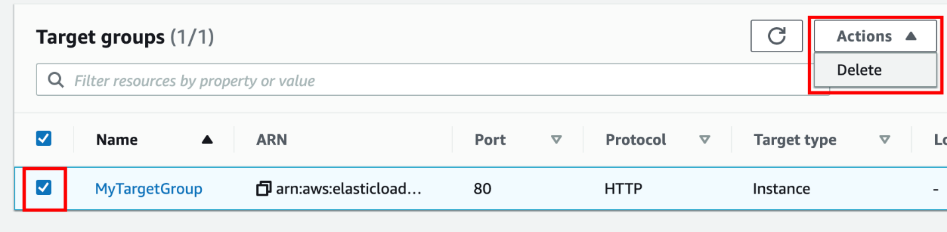
4. Confirm by clicking on the **Yes, delete** button when a pop-up is shown.  
   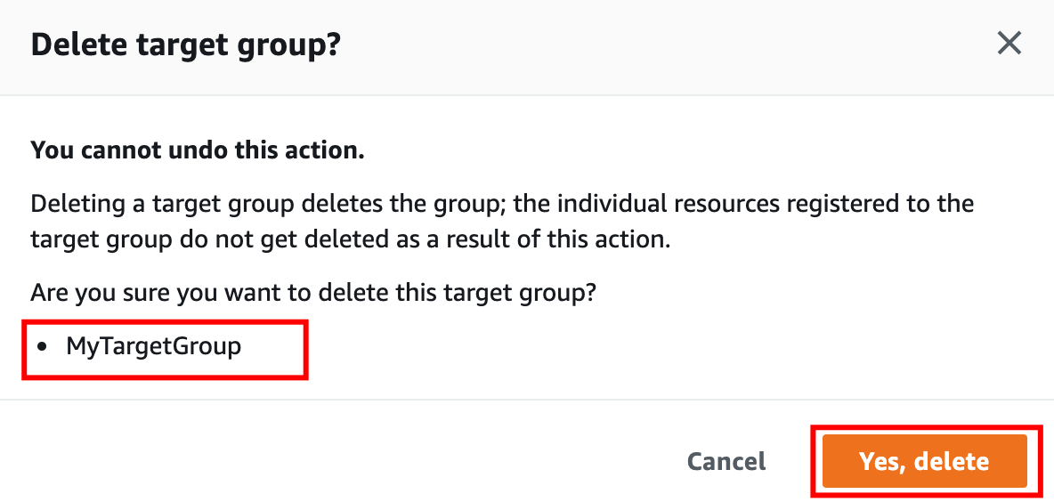
5. **MyTargetGroup**will be deleted immediately.  
   

Deleting EC2 Instances

1. In the EC2 console, navigate to in the left-side panel.
2. 2 EC2 Instance **MyEC2Server1**and**MyEC2Server2** will be listed here.  
   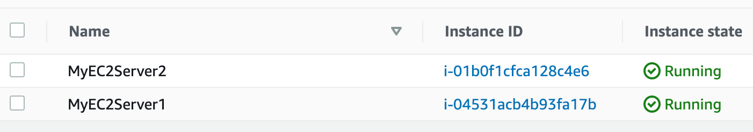
3. To terminate the **EC2 Instances**, need to perform the following actions:
   * **Select** the EC2 instances,
   * Click on the **Instance state** button,
   * select the **Terminate instance** option  
     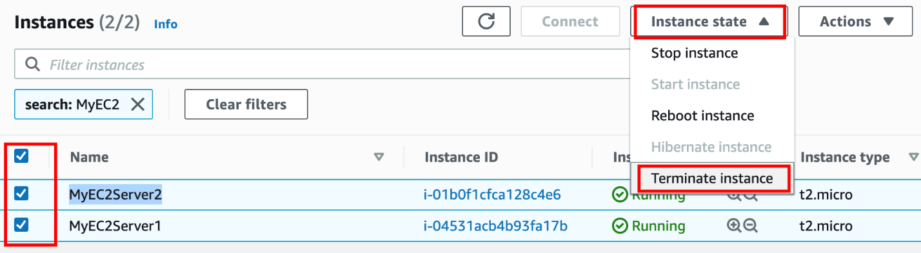
4. Confirm by clicking on the **Terminate** button when a pop-up is shown.  
   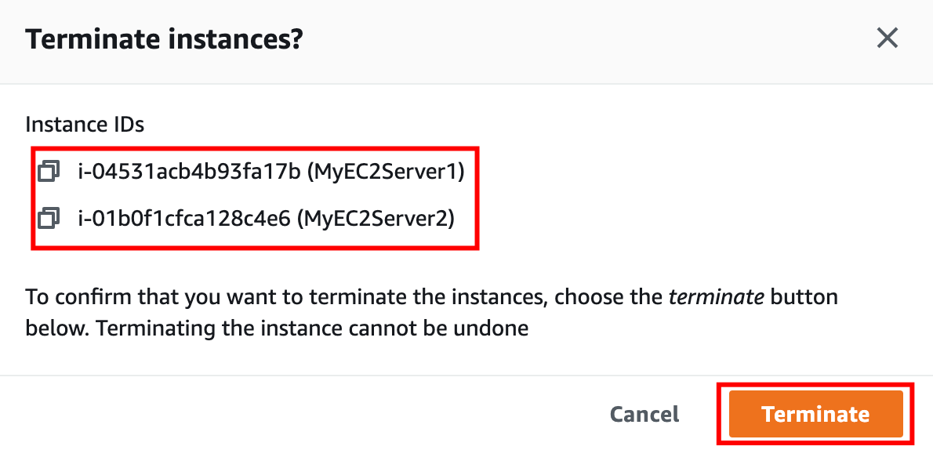
5. **EC2 Instances** will be terminated immediately.  
   

**Completion and Conclusion**

1. You have created two EC2 instances with a bash script that installed Apache servers and created sample HTML pages and published them.
2. You created a Load Balancerand Target group.
3. You added both EC2 instances in the load balancer Target group.
4. You have tested the Elastic Load Balancer by refreshing and simulating a shutdown of an EC2 Instance.

**End Lab**

1. Sign out of the AWS Account
2. You have successfully completed the lab.
3. Once you have completed the steps, click on  from your whizlabs dashboard.